LPN - BSN Library Orientation

Login for CBC computers, CBC-WIFI, NetPrint, Canvas, and remote access to library databases:
Login: Student Email Username
firstnitiallastname# (e.g. rsmith2)
You do NOT need to add the full email address (@students.columbiabasin.edu) for login to the above applications except when logging into your student email
Password: Your Email Password

(EXPIRED PASSWORD could be the reason for login problems).

Try the following:
- Login to a CBC computer
- Connect a personal device to CBC-WIFI
- Use the search function of windows to find “Firefox” or “Chrome” to open a browser
- Login to NetPrint account
- Login to student email and find OneDrive
- Know how to “Sign out” of the computer

Need help? Contact the Student Help Desk – Remote Tech Support
509-543-1445
shelp@columbiabasin.edu

Where are the library resources?

Use the checklist to make sure that you can find and access the following pages:

CBC
- CBC Library main homepage
- CBC Health Sciences Library homepage
- List of Health Sciences databases
- CBC Health Sciences Library Canvas open course
- Locate the “Chat with a Librarian” box
- Try a simple search in the Health Sciences OneSearch
- Find one article on a topic of your interest and get the permalink and APA citation
- Copy and paste the permalink and APA citation in a new document on your OneDrive

Heal-WA
- Find the HEALWA homepage
- Do the first step for setting up access
- Heal-WA Databases page
- Heal-WA Nursing Toolkit page
- Heal-WA ejournals page (try to search for a journal: e.g. Nursing Research)
- Find the CE education page
- Try DynaMed (Only if successfully logged in)

How can I find help?
Ying Yu  Health Sciences librarian  I would love to meet with you for a research consultation through Zoom or in person!  To ask a question or schedule an appointment, simply:  - Email: yyu@columbiabasin.edu , Summer library@columbiabasin.edu  - Email Ying through Canvas inbox | Use the form:  Submit a Question/Request an Online Meeting  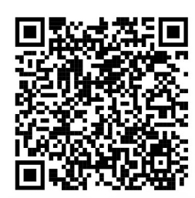
Use the “Chat with a Librarian” box on the right side of the FAQ page (For mobile access, the chat box is at the bottom of the page.)  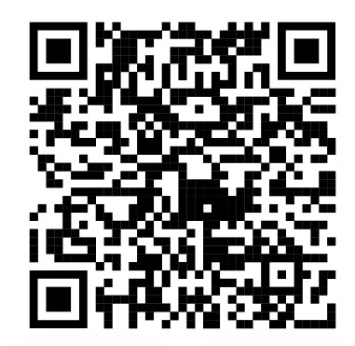 | Use the form: Request an Item  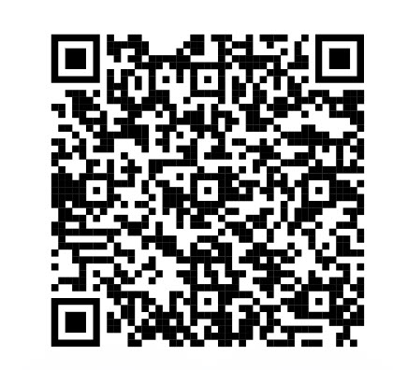

How to scan a QR code:
  - Open your camera on your mobile device
  - Point the camera at the QR code until a yellow URL appears
  - Click on the URL to open the webpage

