Search EBSCOhost’s Academic Search Complete database for articles on college success:
- Run this search http://bit.ly/HDEVresearch to pull up 46,000+ articles, 2011 or newer,
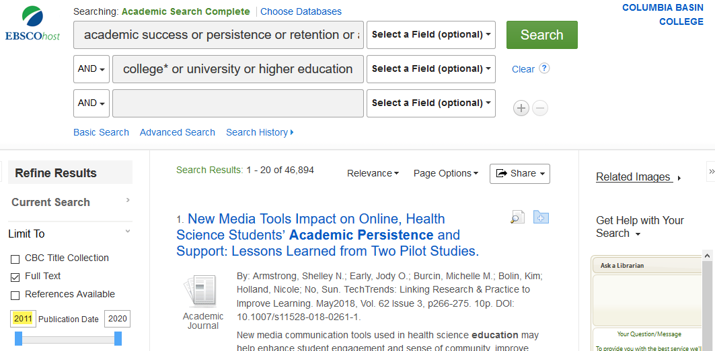
dealing with success (also referred to in the literature as persistence, retention, attainment, so we’ve got the alternate terms on one line with OR between them) in college (again, articles may use the subjects university or higher education).
- Now put your concept on the third line, brainstorming alternate keywords, so for tuition/fees:
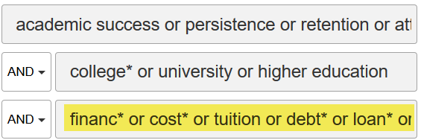
What is the *? EBSCOhost uses the * or SHIFT-8 character as a truncation wildcard, replacing any number of letters at the end, so financ* = finance, finances, financial
List the best keywords/phrases for your subtopic:

Number of results:
TIP: Too few results? Look at the best articles you have and try to find more alternate keywords for your topic. Too many results? Click the + sign to add a fourth line and narrow with another concept, maybe United States or Community College*.
Save your best results (always choose PDF) to your campus MS OneDrive, Google Drive or Flash Drive.
Search EBSCO Discovery Service (http://bit.ly/CBCeds) for articles on your topic:
The Discovery Service searches the Academic Search Complete database plus a *whole* lot more, so look at the best results from your previous searches and use just the top 3 keywords for each concept:
Success | College | Your Subtopic

Use the same techniques as before:
AND between each concept line to narrow your search;
OR between alternate concept keywords on a single line to broaden;
* (Shift-8) at the end of part of a keyword to include the plural or other forms of the word;
Click Search
Limit To on the left side of your results
2011 in the Publication Date
Academic Journals under Source Types
Number of results:
Managing Results:
- Create a draft bibliography
  - Open Word online (or create a Google Doc)
  - Use the tool and copy-and-paste an MLA style citation
  - Use the tool to be sure you have a link that will work off-campus
- Save your PDFs (or use the function to email it as an attachment to yourself)
  - Use the PDF reader download and
    - Save to your flashdrive –OR-
    - Save to the desktop and drag to your CBC/MS OneDrive

