CREATING AN ACCESSIBLE CANVAS PAGE

Overview
This page will show you how to make sure all of your Canvas pages (and assignments, discussions, quiz pages) are accessible.
You have a choice as to how to engage with the material in this lesson. Remember, the key concepts are always addressed in the text. If you need more info or learn by watching, the videos and resources are great supplements.
- Read About It
- Watch a Demo / Video
- Explore Resources on the Web
The Rich Content Editor
The rich content editor in Canvas is one tool that you should become very familiar with. These icons above the pages where you add text, allow you to add headings to your page (much like you do in Word), add images, add tables, videos, lists, etc.
Page Structure
Just as you do in Word, you add structure to a Canvas page by using headings. The page title is Heading 1, so any section heading in Canvas will begin with Heading 2. To add headings, you simply highlight the line of text, then select the appropriate heading.
You check how text has been formatted by highlighting or clicking on a section of text (while in edit mode). At the bottom of the editing pane, you will see a p, h2, or h4 appear. These stand for paragraph (normal text, such as this text), heading 2 (section titles), heading 3 (sub-section), or heading 4 (sub-sub section).
Alternate Text
You're probably sick of hearing about alt text, but guess what - you need it in Canvas, too! Luckily, Canvas makes it easy to add alt text - prompting you to add it when you first add your image (if you're using the rich content editor).
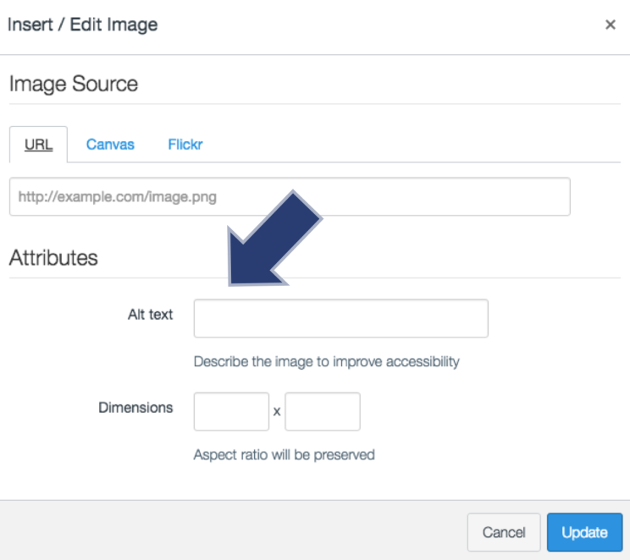
If you're adding alt text to exiting images, click on the image, then click on the image editor icon in the rich content editor to access the alt text field.
If the image is decorative, enter " " into the alt text field (quotation, space, quotation) - this will ensure that a screen reader skips over it. The default alt text is the file name, which can be quite confusing. Leaving the alt text field blank is problematic, as some screen readers will announce that there is an image or graphic, but it will not have any info to convey the purpose of the image.

Tables
Canvas now allows you to edit tables in such a way that you can use the rich content editor to add headings to them (as opposed to going into the HTML to do it!). As discussed with Word, tables should have captions and headings to assist screen readers in reading the data correctly. Tables should not be used to format/control the layout of your page.
Once you've made your table, do the following to make it accessible:
- Click on the table to select it. Then, click on the table icon in the rich content editor.
- Select Table properties and check "caption". Click "Ok".
- Click at the top of your table to type a caption for the table.
- Highlight the cells of the header row (or column).
- Select "Cell", then "cell properties" from the table menu in the rich content editor.
- Select "header cells" from the Cell type dropdown menu.
- Select "columns" (if the headings are by column as below. If it's arranged by row, select rows. If you do both, select both options.) from the scope dropdown menu. Click "Ok".
Review the Canvas Guide for step by step instructions on making accessible tables (Links to an external site.)Links to an external site..

Captions/Transcripts
Another fun function in Canvas is the ability to easily add in audio and video recordings to each page using the rich content editor. However, if you have a student that is deaf, hard of hearing, or simply doing classwork in a noisy environment, you'll want to make sure you also provide captions or a transcript.
I've learned over the years that my recordings are smoother, clearer, and stick to the point when I use a script. And what's even better - that script can now be used to create captions (for a video) or a transcript (for audio).
The next lesson will go over how to caption videos (in Canvas and YouTube), but in the meantime, feel free to review the Canvas Guide on adding captions to Canvas videos (Links to an external site.)Links to an external site..
Accessibility Checker
The New Rich Content Editor includes an accessibility tool that checks common accessibility errors within the editor. You can use the Accessibility Checker to design course content while considering accessibility attributes. This tool only verifies content created within the New Rich Content Editor. You may use other accessibility tools to verify additional content in Canvas.
All accessibility components retain the parameters set by your institution's Theme Editor template. The Accessibility Checker verifies the following accessibility rules:
- Table captions: Tables should include a caption describing the contents of the table.
- Table header scope: Table headers should specify scope and the appropriate structure.
- Table header: Tables should include at least one header.
- Sequential headings: Heading levels should not be skipped (e.g. H2 to H4). However, the tool does not check if the first header starts with H2 or whether the headings are sequential with the rest of the content in the page. Tables do not begin with H1, which is designated for the page title.
- Heading paragraphs: Headings should not contain more than 120 characters.
- Image alt text: Images should include an alt attribute describing the image content.
- Image alt filename: Image filenames should not be used as the alt attribute describing the image content. Currently, files uploaded directly to Canvas create a redirect that does not properly verify image filenames.
- Image alt length: Alt attribute text should contain fewer than 120 characters.
- Adjacent links: Adjacent links with the same URL should be a single link. This rule verifies link errors where the link text may include spaces and break the link into multiple links.
- Large text contrast: Text larger than 18pt (or bold 14pt) should display a minimum contrast ratio of 3:1.
- Small text contrast: Text smaller than 18pt (or bold 14pt) should display a minimum contrast ratio of 4.5:1.

RESOURCES
Using Heading Tags to Improve Accessibility (3 mins)
A short demonstration from Bellingham Tech on how to use headings in Canvas.
Using Heading Tags to Improve Accessibility (Links to an external site.)Links to an external site.
Alternate Text text (3 mins)
In this video, Tom Gibbons will walk you through how to add alt text for images.
Canvas Tip of the Week: Alt Text (Links to an external site.)Links to an external site.
Style Your Syllabus for Accessibility (11 mins)
Another video from South Seattle College's Tom Gibbons! In this video, you'll learn how to format your Canvas syllabus to be accessible for students with disabilities.
Style Your Syllabus for Accessibility (Links to an external site.)Links to an external site.
Canvas Accessibility Guides
- Canvas Guide: General Accessibility Guidelines (Links to an external site.)Links to an external site. (includes links to adding alt text, descriptive hyperlinks, checking color contrast)
- Canvas Guide: Accessible Tables in Canvas (Links to an external site.)Links to an external site.
- Canvas Accessibility (Links to an external site.)Links to an external site. - Provides a good break down of how and why to use the elements discussed above.
- Five Ways to Make Your Canvas Course More Accessible (Links to an external site.)

